- Write simple fact for the statements using PROLOG
  - Ram likes mango
  - Seema is a girl
  - Bill likes Cindy
  - Rose is red
  - John owns gold.

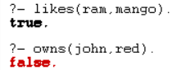

- Write a Prolog program that calculates the sum of integers from 1 to n. Define a predicate ‘sum_up_to_n’ where the first argument is 'n' (an integer) and the second argument is the result of the sum. The sum should be computed recursively.

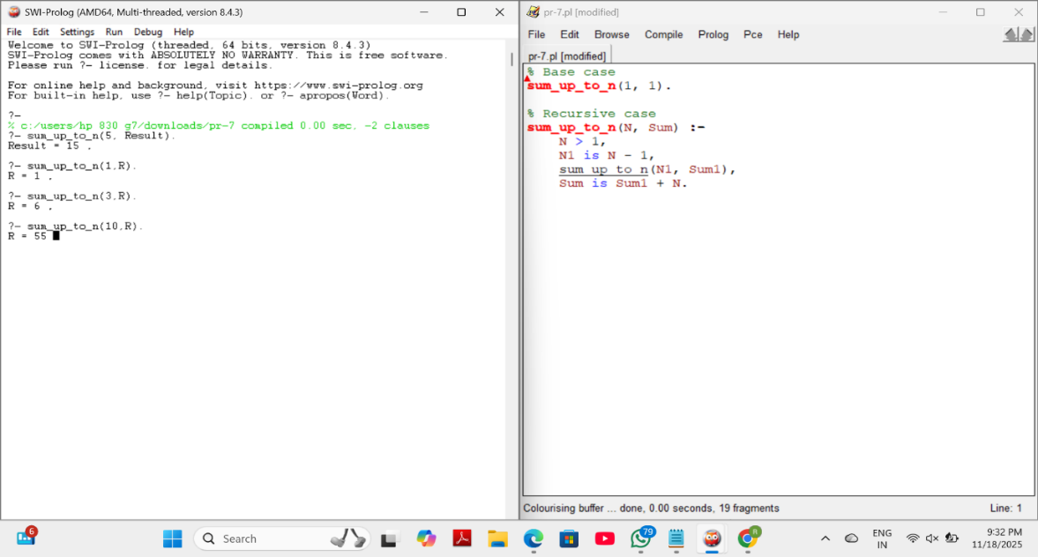

- In the following sections, we'll illustrate constraint programming (CP) by a combinatorial problem based on the game of chess. In chess, a queen can attack horizontally, vertically, and diagonally. The N-queens problem asks:
  - How can 4 queens be placed on a 4x4 chessboard so that no two of them attack each other?

  - For the above problem, you have to show one possible solution using Prolog program.

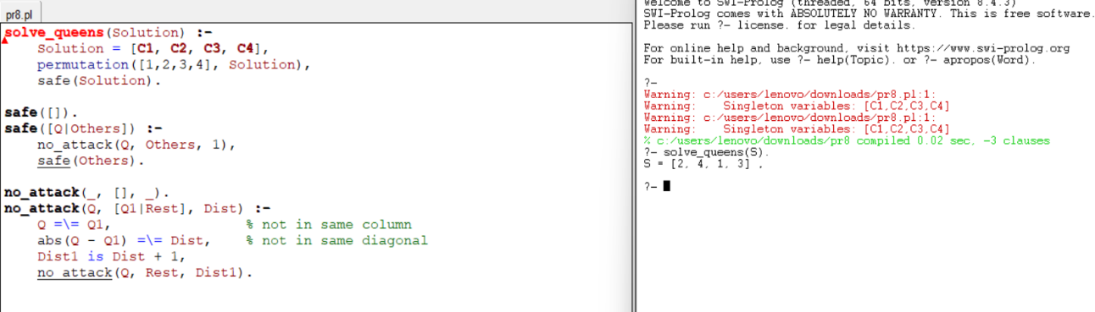
- Write a Prolog program that calculates the factorial of a given number. Your program should include a predicate factorial that takes an input number and computes its factorial. You can use recursion for this task.
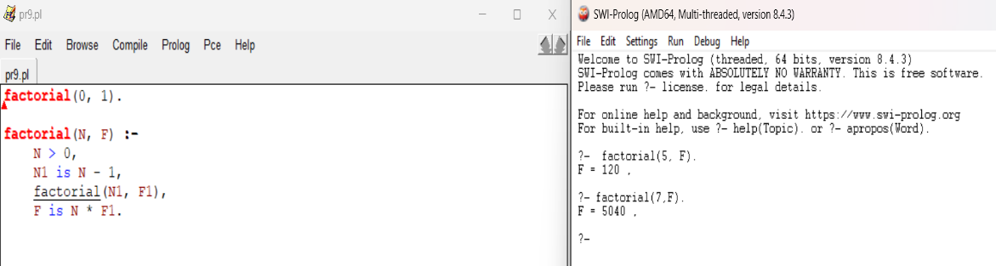

- Write a Prolog program that calculates the nth Fibonacci number. Your program should include a predicate Fibonacci that takes an input position n and computes the Fibonacci number at that position. Use recursion to implement the Fibonacci sequence.

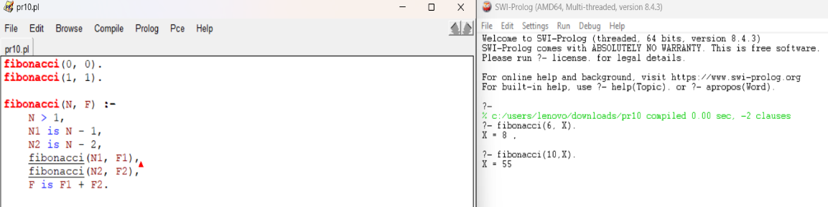

- Write a Prolog query to determine if a specific bird can fly or not. Please provide the Prolog query and its output for the following birds:
  - Sparrow
  - Penguin
  - Eagle
  - Crow (A bird not mentioned in the provided facts).

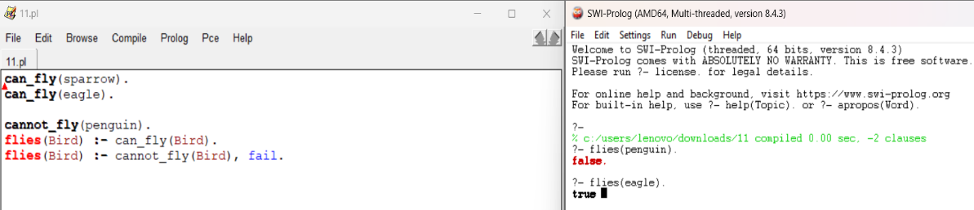

- Imagine you are managing a database that stores information about individuals, including their names and dates of birth (DOB). Define at least five individuals with their names and DOBs. Write Prolog queries to perform the following tasks:
  - Retrieve the DOB of a specific person given their name.
  - Find all individuals who are older than a certain age (e.g., 30 years old) based on their DOBs.
  - Determine who is the youngest person in the database.
  - Check if a specific person is older than another specific person.
  - Your program should include appropriate facts and rules for these tasks. Make sure to provide sample queries for each task as well.

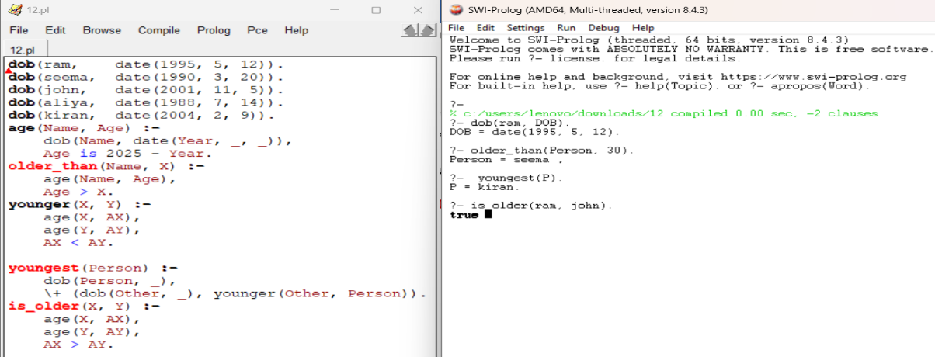

- Create a Prolog program for backward chaining questions, you typically define facts and rules that describe your domain and then use queries to find the answers to specific questions. You have to create a knowledge base about animals and answer questions about whether an animal is a mammal or a bird.

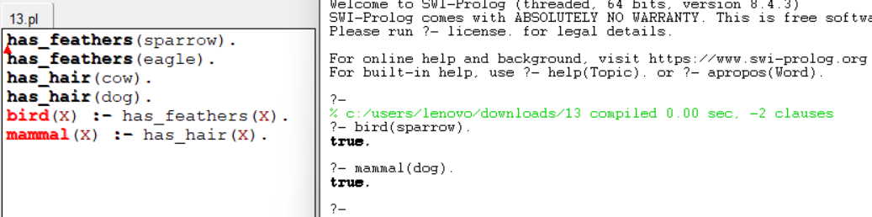

- Create a Prolog program to suggest a dieting system based on a specific disease involves defining rules and facts for different diseases and their corresponding dietary recommendations. Use three common health conditions: diabetes, hypertension, and obesity.

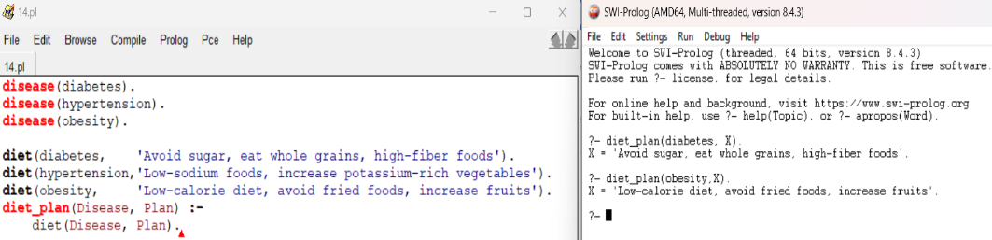

- Using Prolog, you have to solve the problem of finding fruits and their colors using backtracking by defining facts and rules that describe the relationships between fruits and colors. Take sample fruits of 8 no’s.

